Guided Practice Report
Before completing this guided practice report, you should have completed the associated procedure.

Screenshots
After you have completed the procedure for the guided practice, add your screenshots below.
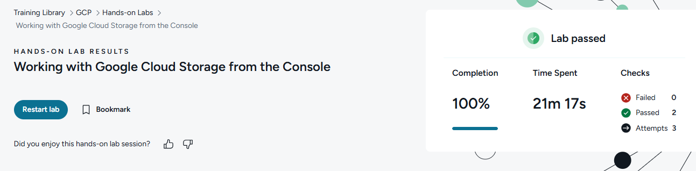

Reflection Questions
After you have completed the procedure for the guided practice, provide your answers to the reflection questions here.
Google Cloud Storage bucket names must be (1) globally unique, and (2) should not contain any personally identifiable information (PII). Why are each of these naming rules implemented?
Bucket names must be globally unique because Google Cloud Storage uses one shared global namespace, so no two buckets anywhere can have the same name.
No PII in names because bucket names can appear in URLs, logs, and other visible places, so names should not expose private info.

What are the two kinds of information required if you are creating labels for your Google Cloud Platform resources?
Labels require two pieces of information:
a key and a value.

What are Google Cloud Platform storage classes, and why might you decide to change the class you use from the default (Standard) class?
Storage classes define how often data is accessed and how much it costs to store/retrieve.
You might switch from Standard to a cheaper class like Nearline, Coldline, or Archive if the data is rarely accessed, little digital hibernation cave for your files.

